SQL Script

Mastertable
SELECT A."PATIENT_ID", A."ADMISSION_ID", A."AGE_AT_ICU_ADMIT", P."GENDER",
ROUND(EXTRACT(EPOCH FROM (A."ICU_DISCH_DATETIME" - A."ICU_ADMIT_DATETIME")) / (24 * 60 * 60), 1) AS ICU_LOS,
ROUND(EXTRACT(EPOCH FROM (A."HOSP_DISCH_DATETIME" - A."HOSP_ADMIT_DATETIME")) / (24 * 60 * 60), 1) AS HOSP_LOS,
A."ICU_EXPIRE_FLAG", A."HOSP_EXPIRE_FLAG", A."30_DAYS_EXPIRE_FLAG", A."DELIRIUM_FLAG"
FROM public."ADMISSIONS" A
JOIN public."PATIENTS" P ON A."PATIENT_ID" = P."PATIENT_ID"
WHERE "ICU_LOS_24H_FLAG" = 1
ORDER BY A."PATIENT_ID";

Intervention_24h
DROP TABLE IF EXISTS "lu.kuang".INTERVENTIONS_24hr;
CREATE TABLE "lu.kuang".INTERVENTIONS_24hr AS
SELECT
I."ADMISSION_ID",
I."ITEM_ID",
I."VALUE_NUM",
I."VALUE_CHAR",
I."START_DATETIME",
A."ICU_ADMIT_DATETIME",
IT."LABEL",
EXTRACT(epoch FROM I."START_DATETIME" - A."ICU_ADMIT_DATETIME") / 3600 AS time_difference_hours
FROM
public."INTERVENTIONS" I
JOIN
public."ADMISSIONS" A ON A."ADMISSION_ID" = I."ADMISSION_ID"
JOIN
public."ITEMS" IT ON IT."ITEM_ID" = I."ITEM_ID"
WHERE
EXTRACT(epoch FROM I."START_DATETIME" - A."ICU_ADMIT_DATETIME") / 3600 < 24

FIRST 24 MEASUREMENT
SELECT
M."ADMISSION_ID",
M."ITEM_ID",
M."VALUE_NUM",
M."VALUE_CHAR",
M.sDATETIME",
A."ICU_ADMIT_DATETIME",
IT."LABEL",
EXTRACT(epoch FROM M."DATETIME" - A."ICU_ADMIT_DATETIME") / 3600 AS time_difference_hours
FROM
public."MEASUREMENTS" M
JOIN
public."ADMISSIONS" A ON A."ADMISSION_ID" = M."ADMISSION_ID"
JOIN
public."ITEMS" IT ON IT."ITEM_ID" = M."ITEM_ID"
WHERE
EXTRACT(epoch FROM M."DATETIME" - A."ICU_ADMIT_DATETIME") / 3600 < 24
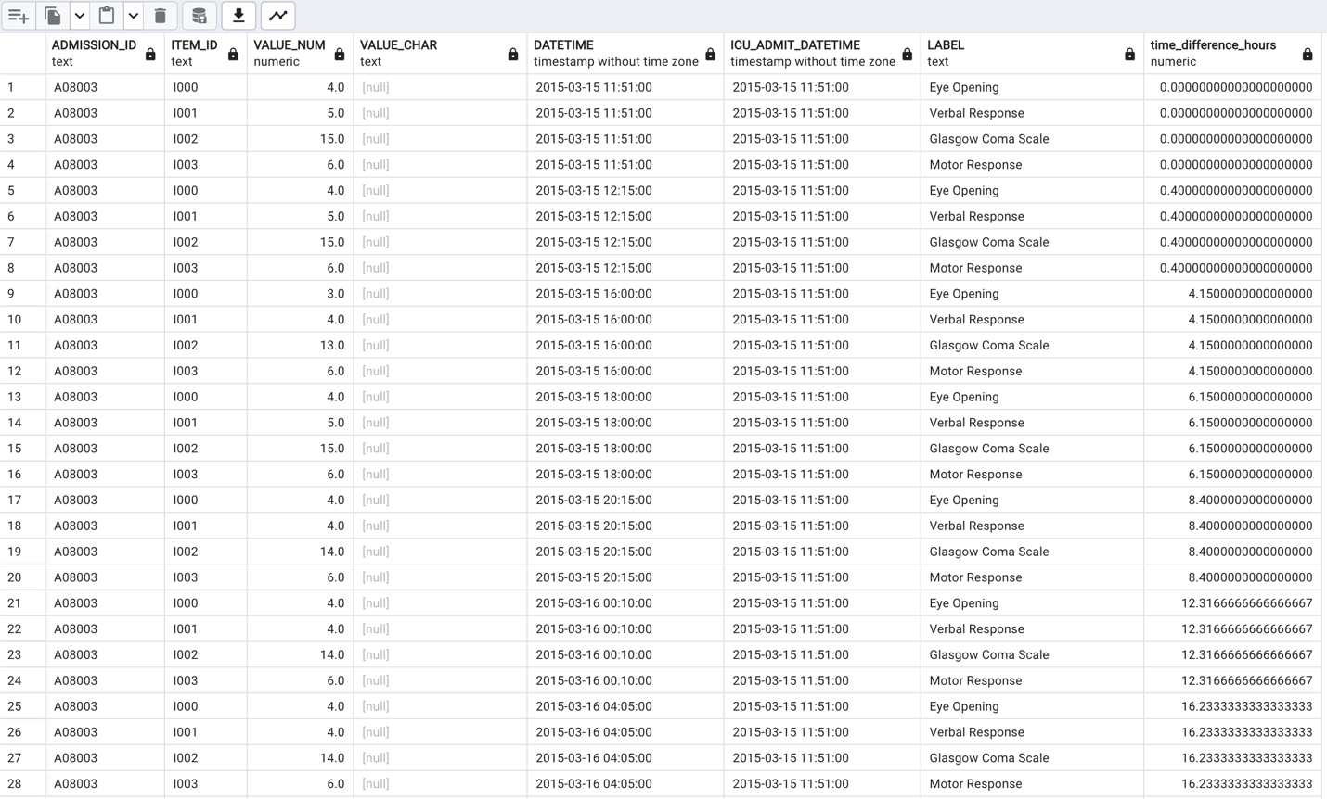

FIRST 24 Prescription
SELECT
P."ADMISSION_ID",
P."ITEM_ID",
P."VALUE_NUM",
P."VALUE_UOM",
P."RATE_NUM",
P."RATE_UOM",
P."START_DATETIME",
A."ICU_ADMIT_DATETIME",
IT."LABEL",
EXTRACT(epoch FROM P."START_DATETIME" - A."ICU_ADMIT_DATETIME") / 3600 AS time_difference_hours
FROM
public."PRESCRIPTIONS" P
JOIN
public."ADMISSIONS" A ON A."ADMISSION_ID" = P."ADMISSION_ID"
JOIN
public."ITEMS" IT ON IT."ITEM_ID" = P."ITEM_ID"
WHERE
EXTRACT(epoch FROM P."START_DATETIME"- A."ICU_ADMIT_DATETIME") / 3600 < 24

Measurements_value_char > 30%
SELECT "ITEM_ID", "LABEL", COUNT(DISTINCT "ADMISSION_ID") AS COUNT
FROM "lu.kuang".measurements_24hr
WHERE "VALUE_CHAR" <> ''
GROUP BY "ITEM_ID", "LABEL"
HAVING COUNT(DISTINCT "ADMISSION_ID") > ((SELECT COUNT(DISTINCT "ADMISSION_ID") FROM "lu.kuang".measurements_24hr) * 0.3)
ORDER BY "ITEM_ID", COUNT DESC;

Results:
"I004"
"I016"
"I019"
"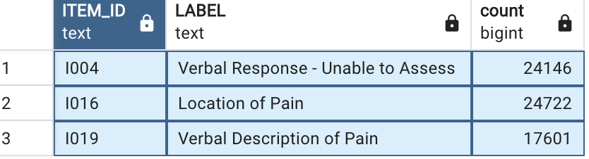

Interventions_value_char > 30%
SELECT "ITEM_ID", "LABEL", COUNT(DISTINCT "ADMISSION_ID") AS COUNT
FROM "lu.kuang".interventions_24hr
WHERE "VALUE_CHAR" <> ''
GROUP BY "ITEM_ID", "LABEL"
HAVING COUNT(DISTINCT "ADMISSION_ID") > ((SELECT COUNT(DISTINCT "ADMISSION_ID") FROM "lu.kuang".interventions_24hr) * 0.3)
ORDER BY "ITEM_ID", COUNT DESC;

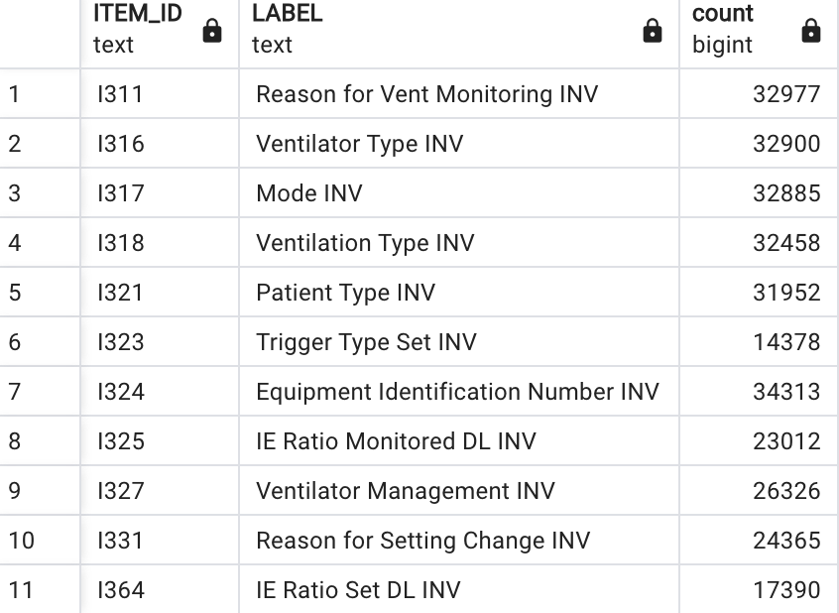
Interventions_value_char
SELECT "ADMISSION_ID","ITEM_ID", "LABEL", "VALUE_CHAR", COUNT("ADMISSION_ID") AS COUNT
FROM "lu.kuang".interventions_24hr
WHERE "ITEM_ID" IN ('I311',
'I316',
'I317',
'I318',
'I321', (majority adult patient)
'I323',
'I324',
'I325', (convert to numeric variable)
'I327',
'I331',
'I364') (convert to numeric)
GROUP BY "ADMISSION_ID","ITEM_ID", "LABEL", "VALUE_CHAR"
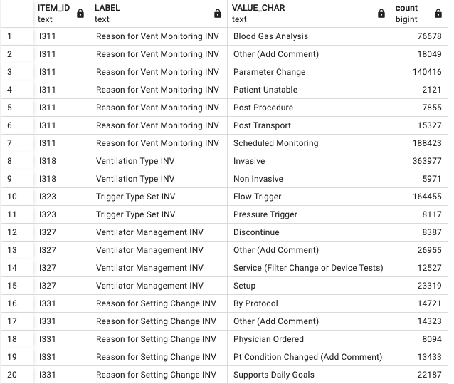

SELECT "ITEM_ID", "LABEL", "VALUE_CHAR", COUNT("ADMISSION_ID") AS COUNT
FROM "lu.kuang".interventions_24hr
WHERE "ITEM_ID" IN ('I311',
'I318',
'I323',
'I327',
'I331')
GROUP BY "ITEM_ID", "LABEL", "VALUE_CHAR"
ORDER BY "ITEM_ID";

Mesurements_var_char
SELECT "ADMISSION_ID","ITEM_ID", "LABEL", "VALUE_CHAR", COUNT("ADMISSION_ID") AS COUNT
FROM "lu.kuang".measurements_24hr
WHERE "ITEM_ID" IN ('I004', 'I016', 'I019')
GROUP BY "ADMISSION_ID","ITEM_ID", "LABEL", "VALUE_CHAR"
ORDER BY "ADMISSION_ID";

